In The Walsh Library: Notes On The State Of Virginia By Thomas Jefferson
Monday, April 10, 2017
By Michael Giorgio
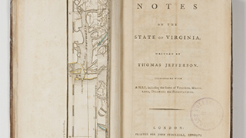One need not venture far to literally touch history first-hand. The Archives and Special Collections Center in the University Libraries contain a wealth of significant pieces that tell the stories that shaped our country and the world. A recently restored 1787 edition of Thomas Jefferson's Notes on the State of Virginia is now on display and readily available for any student, academic or history aficionado who has a desire to get closely acquainted with one of our greatest founding fathers.
This was the first English-language edition of the text that was made widely available. (Its very first printing in 1785 was a small run of only 200 copies, which Jefferson distributed himself to friends and colleagues.) Notes on the State of Virginia was the only one of Jefferson's books to be published in his lifetime, under his supervision. The copy held by the Archives and Special Collections Center still contains the fold-out maps and tables, which were frequently removed from this type of work in the past and are rarely found intact.
While the book is overall well preserved, at 230 years old it was in need of some conservation treatment in order to make it stable enough for handling and display. Issues such as desiccated leather covers, poorly affixed black cloth tape as binding and multiple tears and creases to the fold-out map were addressed through restoration work by the Conservation Center for Art and Historic Artifacts (CCAHA) in Philadelphia.
Using a variety of techniques to correct the condition issues while preserving as much of the original materials as possible, Conservators at CCAHA successfully repaired the book in a manner that retains the original character while greatly improving its stability.
Among the many other exhibits and collections at the Archives and Special Collections Center, notable are The Newark Uprising of 1967 – An Exhibit Overview and Resource Leads that chronicles the historic civil unrest and resulting riots in Newark, N.J.; Women of Setonia 1937 – Ever Forward, marking the 80th anniversary since women first attended lectures or taught courses at Seton Hall; and I Fioretti Di S. Francesco, a 1926 copy of a collection of readings about St. Francis, compiled by an unknown author in the 14th century featuring illustrations and covers created by Italian Art Nouveau artist Duilio Cambellotti.
The treasures of the past are given new life through the Archives and Special Collections Center in the University Libraries. Do not miss the opportunity to explore and learn from them while you are on campus.
Find out more about the Archives and Special Collections Center here.
Categories: Arts and Culture

List of archival collections from Seton hall “Walsh library”
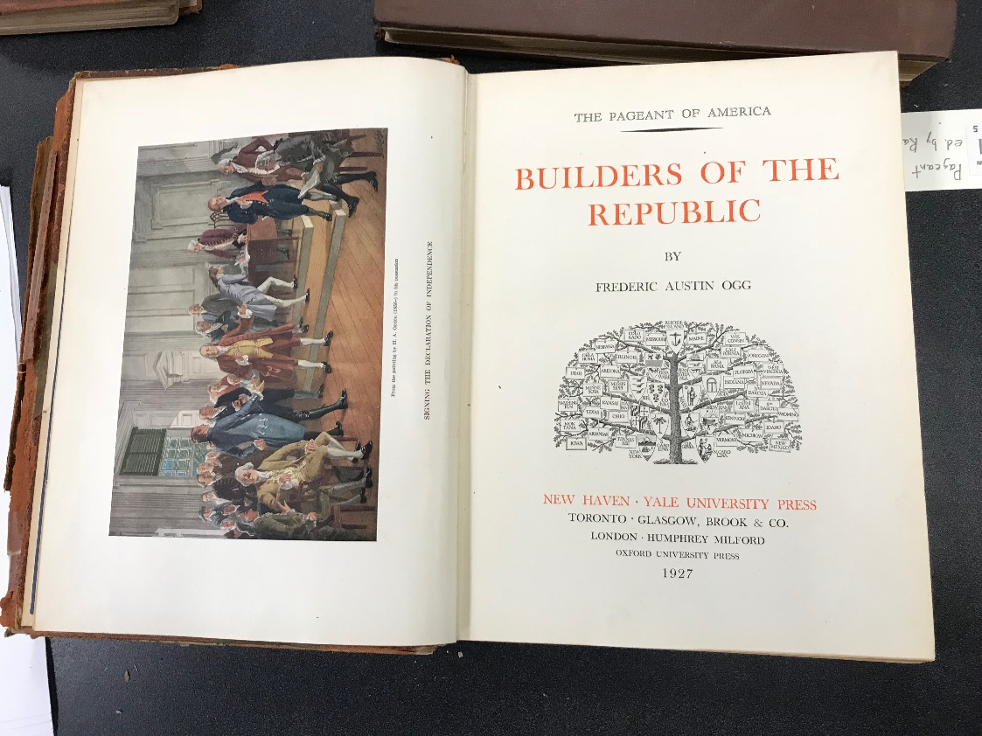
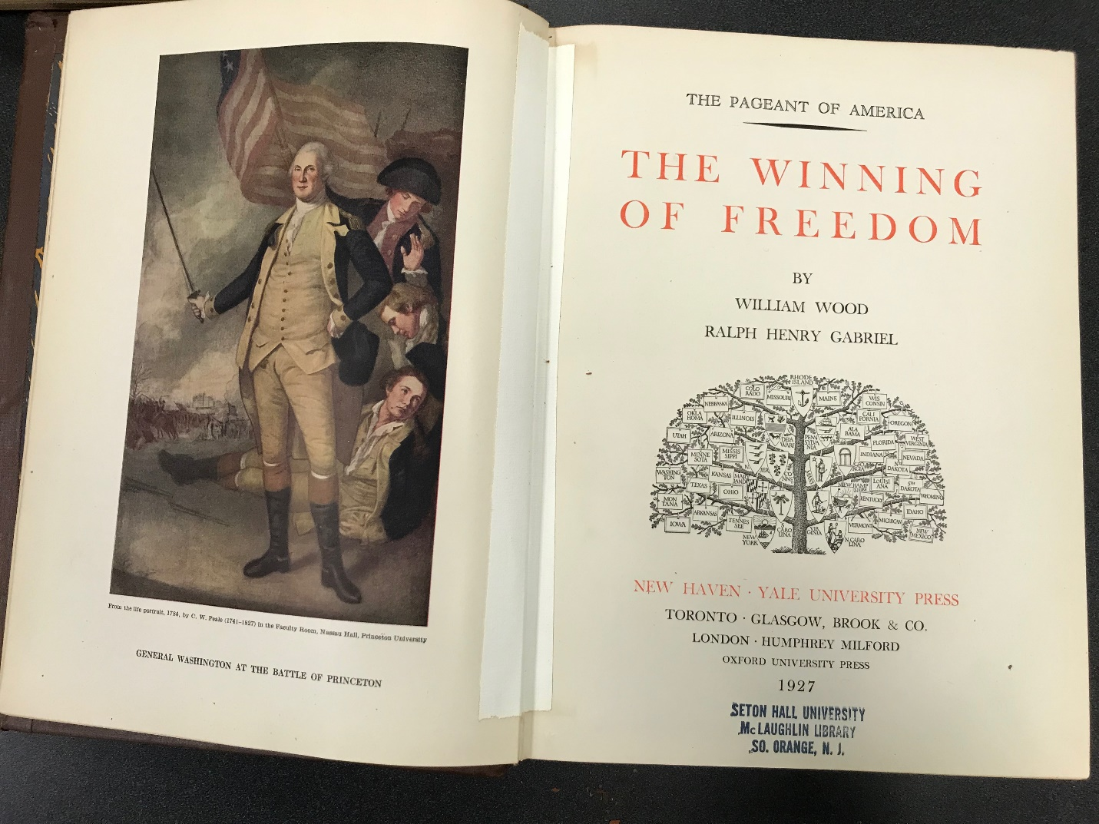

Photograph
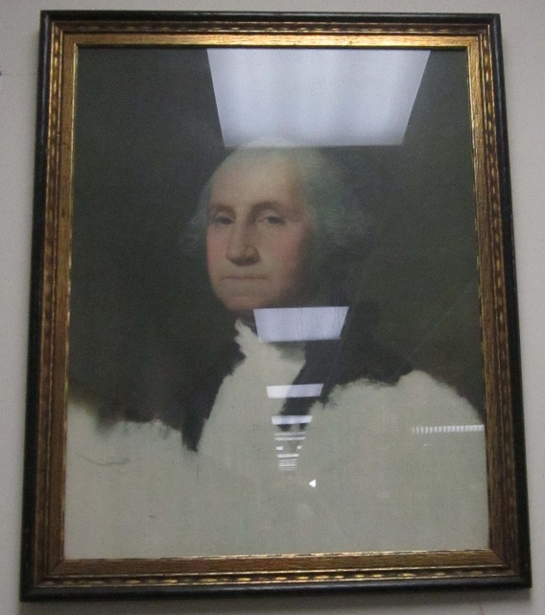
Look at the in formation of this picture down
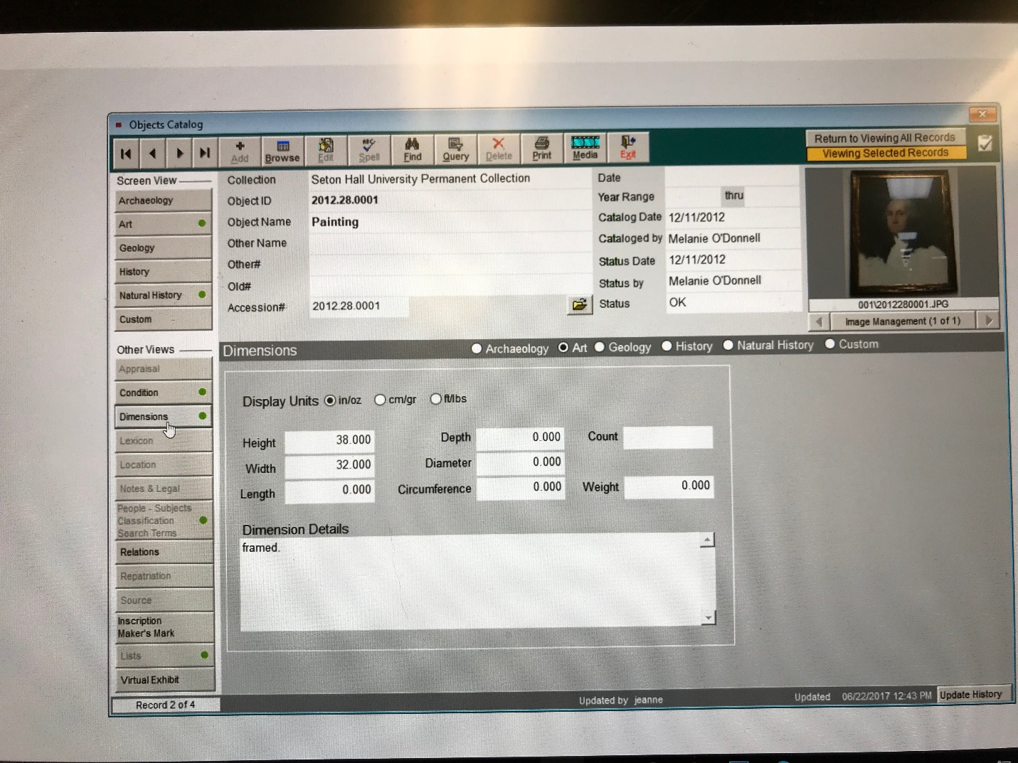

 Review: "The most successful and resourceful portraitist of America's early national period, Gilbert Stuart (1755-1828) possessed enormous natural talent, which he devoted to the representation of human likeness and character, bringing his witty and irascible manner to bear on each of his works, including his incisive portraits of George Washington. This publication accompanies a retrospective exhibition of Stuart's work, the first since 1967, and takes the standpoint that investigation of Stuart's sitters reveals the artist's practice of portraiture. His clients were facilitators of his progress, and knowledge of them is crucial to interpreting the artist's unique talents.

The organization of this study follows Stuart through the eight cities in which he worked: Newport and Scotland (1755-75), London (1775-87), Dublin (1787-93), New York (1793-94), Philadelphia (1794-1803), Washington (1803-5), and Boston (1805-28). A short essay about the artist's experience in each city precedes catalogue entries on more than ninety portraits, all illustrated in color. A special section is devoted to Stuart's celebrated portraits of George Washington."--Jacket.
Content Notes:
Making faces: Gilbert Stuart and his portraits -- Stuart in Newport and Scotland (1755-75) -- Stuart in London (1775-87) -- Stuart in Dublin (1787-93) -- Stuart in New York (1793-94) -- Stuart in Philadelphia (1794-1803) -- Stuart in Washington (1803-5) -- Stuart in Boston (1805-28).
Notes:
"Catalog of an exhibition at the Metropolitan Museum of Art, New York, Oct. 18, 2004-Jan. 16, 2005 and at the National Gallery of Art, Washington, D.C., Apr. 10-July 31, 2005."
Exhibition at the Metropolitan Museum of Art, New York, Oct. 21, 2004-Jan. 16, 2005 and at the National Gallery of Art, Washington, D.C., Mar. 27-July 31, 2005.
Includes bibliographical references and index.
STH New Full 04182017

http://eds.b.ebscohost.com/eds/detail/detail?vid=8&sid=64d8b793-0b81-456f-affa-23986d92bcd4%40sessionmgr103&bdata=JkF1dGhUeXBlPWNvb2tpZSxpcCxzc28mc2l0ZT1lZHMtbGl2ZQ%3d%3d#AN=sth.ocm55286303&db=cat00991a
Language:

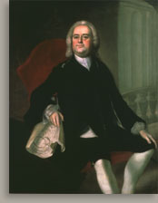

PAINTINGS
Blackburn, Joseph (American, ca. 1730-after 1778)
Portrait of Benjamin Green, 1756
Oil on canvas
frame: 59 1/2 x 47 in. (151.1 x 119.4 cm) painting: 50 x 40 in. (127 x 101.6 cm)
Museum purchase; Clayton E. Freeman Fund
1957.1
Reflecting the cultural background of the colonists, eighteenth-century American painting followed English conventions, which centered on portraiture. Joseph Blackburn was one of the most talented artists in New England. He was active in the Colonies from around 1754 until competition from John Singleton Copley compelled him to move to Bermuda, before returning to Britain in 1762 or 1763. Blackburn's companion portraits of Benjamin and Margaret Pierce Green, painted in Portsmouth, New Hampshire, display the soft pastel colors and graceful brushwork which typify European rococo painting. Blackburn's emphasis on the couple's opulence rather than their individual personalities is also imported. As a testament to the colonists' desire to link with European culture, Greene poses with a document from "George the [II of Great Britain]," perhaps commemorating his role in seizing Louisbourg, Nova Scotia, from the French. Despite their pretensions, Blackburn's American-born sitters seem uncomfortable in the stock poses and lavish surroundings copied from English portraiture.

